MAPPING WAYFINDING STRATEGIES FOR EMERGENCY SERVICES
De Temmerman, L., Van de Weghe, N. & De Maeyer, Ph.
Department of Geography, Ghent University, Belgium
Leen.DeTemmerman@UGent.be, Nico.VandeWeghe@UGent.be & Philippe.DeMaeyer@UGent.be

The focus of this research is to investigate the wayfinding strategies and route choices for emergency services, in particular police services. In order to achieve this objective, during several months, members of the police force of Ghent (Belgium) registered their routes using a GPS device. The recorded tracks were analysed and compared with theoretically calculated paths, like the shortest path (Dijkstra, 1959) and fastest path, calculated by different route planning software. Analysis revealed that the route followed by experienced police officers and the theoretically computed paths linking the two nodes in the street network often differ significantly. After analysing all the data, the paper presents which theoretical path matches best the human behaviour.

1. INTRODUCTION
The zonal steering point or radio room is the core of the local police organizations in Belgium. The radio room is operational 24 hours per day, 7 days per week. The operators working there receive calls coming from the communication and information centre of the federal police, which receives the emergency calls 101 and 112 and is on-line connected with the different zonal steering points, and calls directly coming from the population, mostly calls with lower priority. For this study, the authors collaborated with the local police zone of Ghent, a city in the Flemish part of Belgium counting 233 925 inhabitants (National Institute of Statistics, 2006 July 1st). The local police zone of Ghent, comprising about 1000 staff members, itself is responsible for the dispatching (http://www.gent.be). Under the expert guidance of a police commissioner, the tasks are assigned to the different operational units, according to their nature and urgency. Once the police officers of the intervention unit receive there task, they can start their journey to the intervention place. To find their way, the drivers can make an appeal to different aids like a road book or they can ask directions through radio contact. At present, most police cars are not (yet) equipped with GPS navigation devices; this is due to budgetary limits. For this study, a group of experienced police officers who are very familiar with the road network of Ghent were selected. During three months, the trajectories followed by these policemen/women during their job, were registered. We consider these trajectories as the ‘best route’ from the starting point- this is the place where the police vehicle was located at time the officers were dispatched to there next assignment- to the end point, namely the location where the intervention will take place. The assumption that the recorded routes are the ‘best routes’ can be justified by the fact that (1) the drivers know the road network very well and (2) due to their professional commitment, it is of the utmost importance that the emergency services reach the scene of intervention as quickly as possible, reckoning with the general traffic safety.
The purpose of this study is to analyze the route choices made by these experienced drivers through comparing these trajectories with different trajectories calculated by diverse route planners. Although some research has been conducted by mainly psychologists on mental mapping and wayfinding issues (Golledge, 1998), technical and practical studies, linking the cognitive aspects with computer-controlled routing systems are lacking (Jackson and Kitchen, 1998; Kitchen and Blades, 2002). This study was designed to compare the different calculations of several route planners on the one hand and to compare the theoretically computed routes with the paths chosen by the police officers on the other hand.

2. DATA COLLECTION AND PREPARATION
The data was collected in collaboration with the police zone of Ghent, using GPS devices. The GPS devices should meet several requirements:
- tracking capacity and enough memory to save the trajectories of more or less one week;
- no route planning/ navigation possibilities, so that the officers could not use the device for wayfinding;
- relatively accurate: ± 10 m in x en y, in order to be able to map the GPS tracks on the actual road network;
- user friendly;
- budget friendly;
- possibility to transfer data to pc.
After feeling out and analyzing the market supply, the GARMIN GPS 60 turned out to be the best option for this research. This device can log 10 000 trackpoints, each record containing the position (latitude and longitude), point of time, altitude, leg length, leg time, leg speed and leg course. The GPS 60 was adjusted so that the registration of the routes occurs in latlong WGS84, fixing a point every 10 m. The advantage of this last choice is that no recording occurs when the vehicle is stationary, and that due to the high degree of detail, little difficulties are experienced when mapping the GPS tracks to the road network.
The Tele Atlas MultiNet map database, a highly accurate reproduction of the street network, was used as the road network in the GIS project. It would lead too far to discuss the whole structure of the MultiNet database; we refer to the Data Specification Document accompanying the MultiNet database (Tele Atlas MultiNet Version 3.4.1 Data Specification). Each road segment contains several attributes. One of these attributes is the Net 2 Class classification and is defined here because it is especially relevant for this study. The Data Specification Document explains that “Net 2 Class is the database representation of a classification of roads and ferries based on the importance that the constituting roads and ferries have in the total network. Net 2 Class represents a classification of seven networks of roads and ferries, based on their importance, which each forms a connected graph together with the higher Net 2 Class(es).” So, the Net 2 Class is a kind of importance classification or hierarchy of connected road segments.
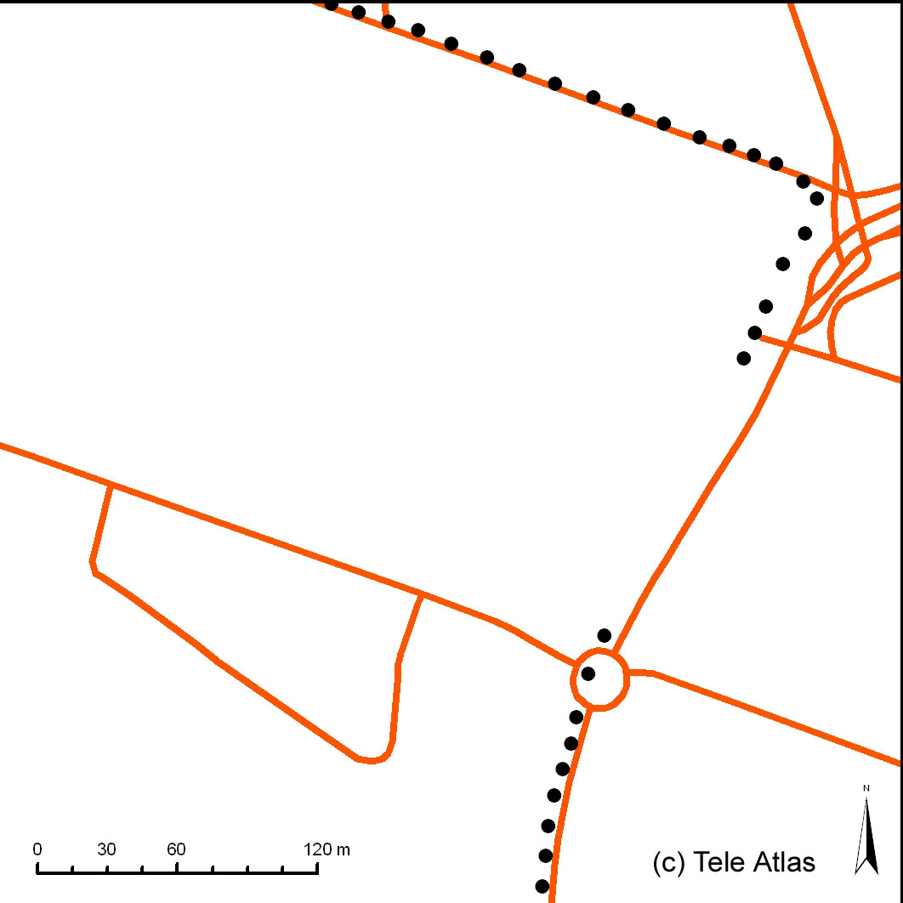

Figure 1: Road network (red lines) and GPS tracks (black dotted line), showing a gap because of satellite disconnection due to tunnel passage.

In total, 261 trajectories were registered between July 2006 and October 2006. A script has been written to import five randomly selected routes into ARCGIS (figure 2), and transform them into the Belgian Lambert72 coordinate system. The routes appear on the screen as dotted lines with 10 meter interval, displaying some gaps where disconnection with satellites occurred (figure 1). Very rarely, these missing points formed a hindrance to match the recorded routes and the road network database manually. Since the dataset is limited, manual processing of the GPS tracks is possible and avoids various difficulties involving automatic data handling (Du and Aultman-Hall, 2007).
Next, ten commonly used route planners available on the internet were selected; the selection occurred mainly based on the research results of Poppe, E. (2001). Table 1 summarizes the ten applications, including the employed map database and the main options (mainly shortest and fastest route) that can be selected by the user. The starting point and the finishing point of each of the five paths were introduced into the ten route planners, after which for every routing system all possible routes (e.g. fastest, shortest,…) were calculated. The results were digitized manually in the GIS project to make the omparison with the former implemented GPS tracks possible.
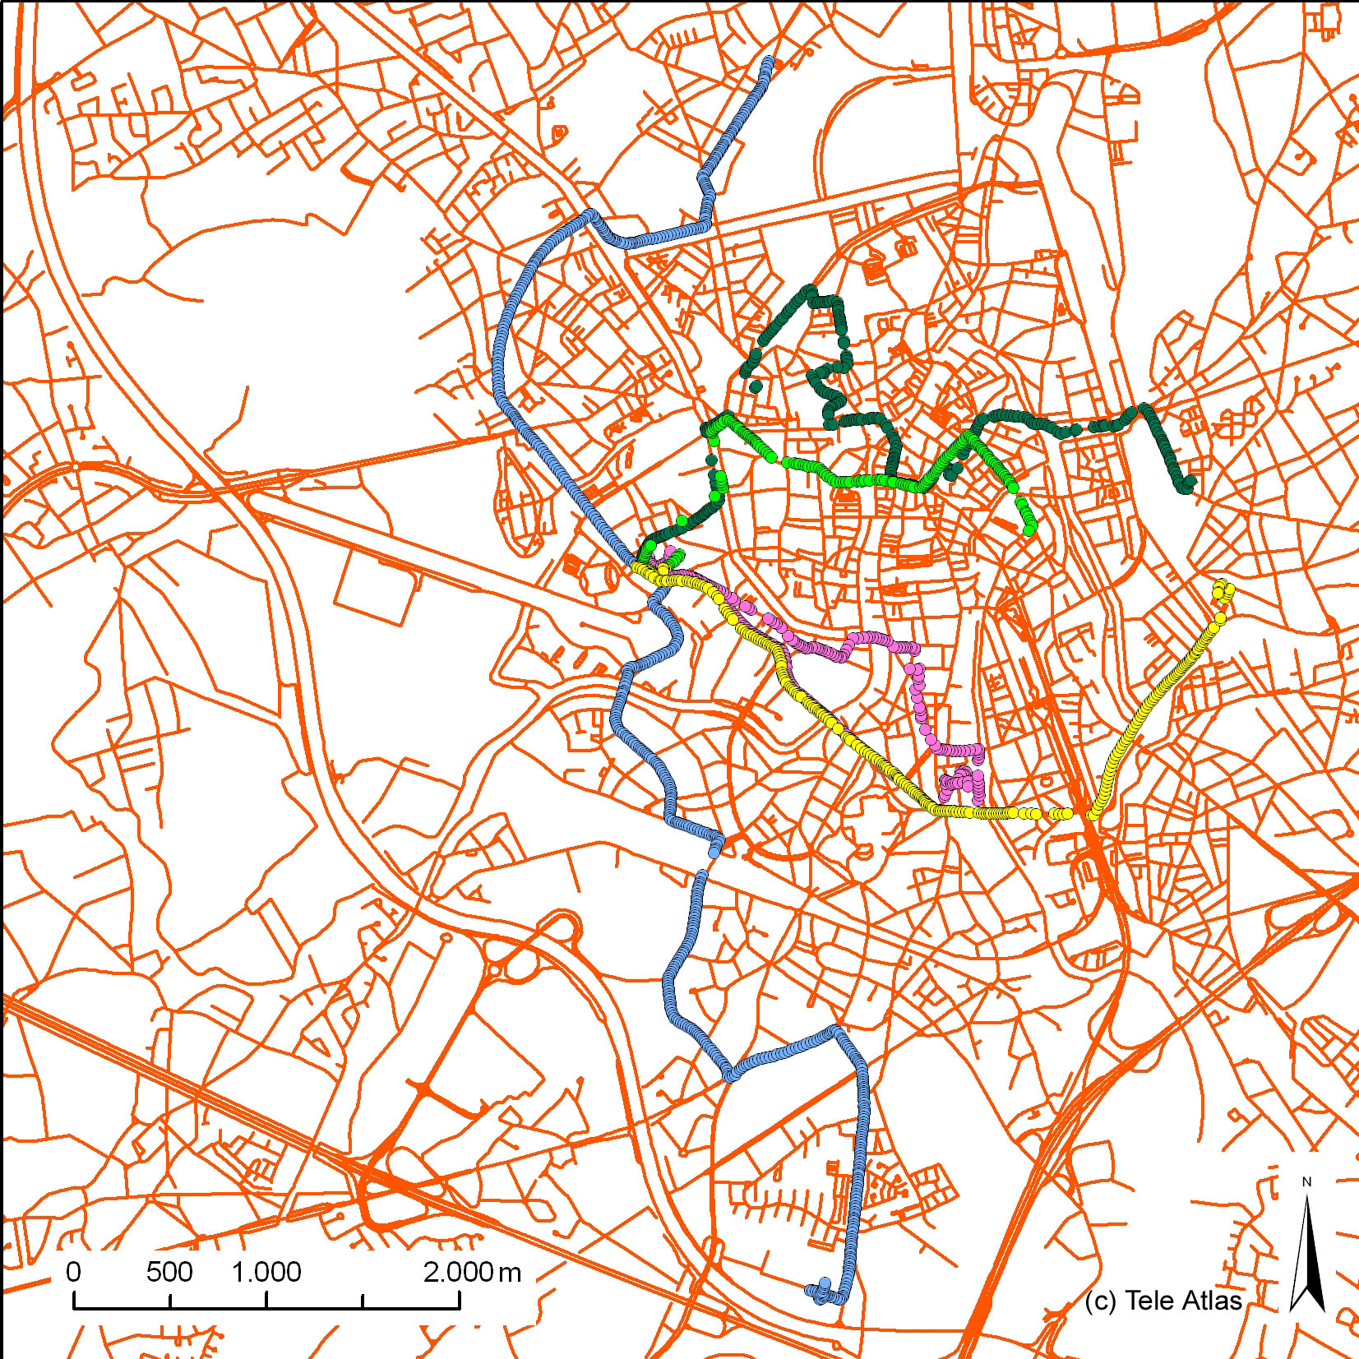
Figure 2: Five selected routes followed by the police. The blue track is the trajectory form the Anjelierstraat 50 to the Ebergiste De Deynestraat 1, used as an illustrative example.
Route planner | Map database | Option/criteria | URL (May 15th 2007)
Mappy | Teleatlas | car, highway (=only option) | www.mappy.com
ViaMichelin | Teleatlas | recommended by Michelin | www.viamichelin.be
 |  | quickest
 |  | shortest
 |  | economical
 |  | discovery
Map24 | Teleatlas/Navteq/Europa Technologies | fastest | map24.geoloc.be
 |  | shortest
ANWB | Navteq, Falkplan | fastest | route.anwb.nl
 |  | alternative
 |  | shortest
Routenet | Teleatlas | optimal | www.routenet.be
 |  | fastest
 |  | shortest
Tripzoom | Teleatlas | optimal | www.tripzoom.nl
 |  | fastest
 |  | shortest
RAC | Navteq, Mapsolute | fastest | www.rac.co.uk/web/routeplanner
 |  | shortest
Multimap | Teleatlas | quickest | www.multimap.com
 |  | shortest
Mapquest | Navteq | shortest time | www.mapquest.com
 |  | shortest distance
Itimap | Teleatlas | fastest | www.itimap.com
 |  | shortest
Table 1: Ten routing systems with their map database, possible calculation options and URL.

3. DATA ANALYSES BY MEANS OF AN ILLUSTRATIVE EXAMPLE
This study was designed to compare routing systems with each other on the one hand, and to compare the reality- that are the wayfinding choices of police units- with the theoretically calculated paths on the other hand.
Two major categories in theoretically computed paths can be distinguished: the fastest/quickest path and the shortest path (Dijkstra, 1959; Fu et al, 2006). Supplementary, some route planners give the user the opportunity to calculate for example a discovery path (ViaMichelin), an alternative path (ANWB) or an optimal path (Routenet and Tripzoom). In this paper, only the first two categories are discussed because the fastest and shortest route can be calculated in each of the ten selected routing systems, except for one (Mappy).
One of the five selected paths was used to illustrate the outcome of the study, namely the trajectory form the Anjelierstraat 50, situated north from the historical centre of Ghent, to the Ebergiste De Deynestraat 1, in the south of the centre (figure 2). A straight line connecting these two points forms an almost perfect north-south axis through the city. In this section, the fastest and shortest route calculations and the ‘police reality’ are described and discussed.

3.1. The fastest route
3.1.1. Routing systems: interrelation
Three groups can be distinguished: it appears that a first group (purple striped line in figure 3) aims to reach a road belonging to the highest level in the importance classification (for Tele Atlas MultiNet Net 2 Class, this is class 0) as quickly as possible; this is the road segment with class 0 within the shortest distance along the network to the starting point. The routing system RAC uses this method and often gives erratic results. The mean of all fastest routes computed by the nine routing systems gives for the time factor 16 minutes and for the distance factor 12.2 km. We mention here that Mapquest could not locate the ending point of the trajectory, namely Ebergiste De Deynestraat, and thus consequently is not included in the analysis. RAC computes respectively 21 minutes and 19.7 km. This route is far from the quickest or the shortest route. This odd result is even more apparent when performing a visual analysis in the GIS project; it is clear that this route differs significantly from all the other routes and even ‘feels’ illogical (figure 3). One can state these routing systems overrate the importance of the highest hierarchy in the importance classification.
A second group (green tracks in figure 3) also requires ascending in the importance hierarchy quickly, but in ‘a more logical way’. These route planners do not want to locate the shortest connection between the starting point and a high class road segment at any price. They also take into consideration other possible, often longer, connections, which result in more ‘logical’ routes.
A last group (blue tracks in figure 3) does not necessarily want to incorporate the highest importance class road segments (class 0 and 1 when using TeleAtlas MultiNet Net 2 Class). Therefore, calculated routes contain less roads with a high connectivity function, they contain less ‘important’ roads. In the urban study area, this leads up to trajectories going through the city centre instead of following major roads going around the city centre, often ring roads.
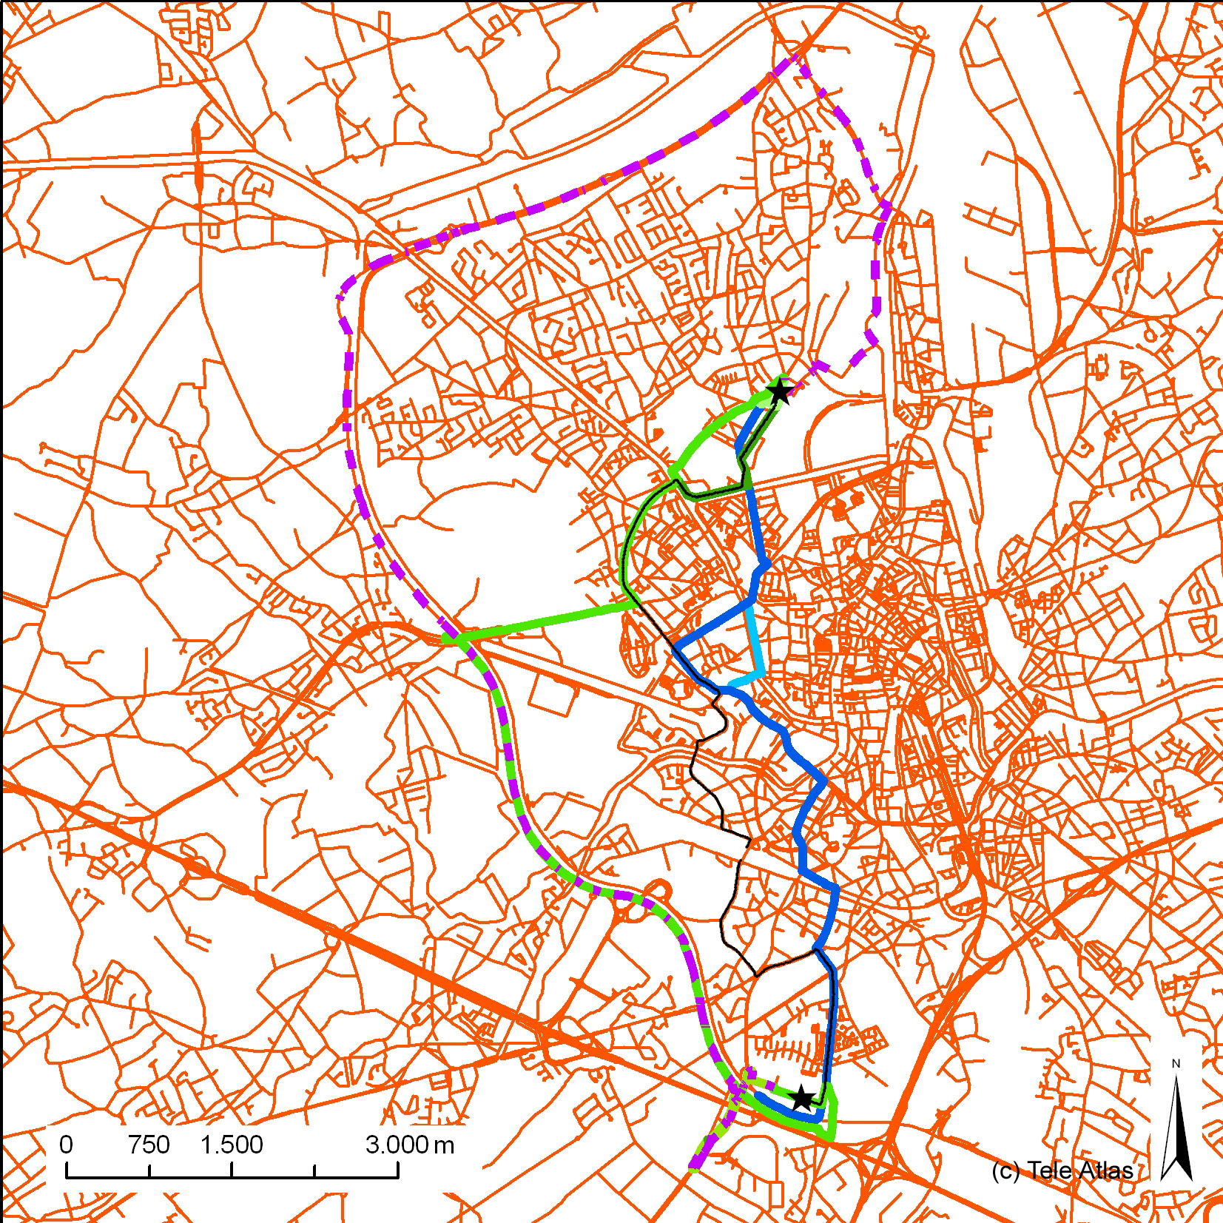
Figure 3: The calculated fastest routes, subdivided into three categories, visualised by different colours (group 1: purple stripes, group 2: green gradations, and group 3: blue gradations). The trajectory chosen by the police officers is shown in black. Starting and ending node are symbolised by a star, the northern star being the starting point.

3.1.2. Routing systems versus reality
First, we can state that the route followed by the police officers (called ‘real’ route) does not fit any of the computed fastest routes (figure 3). Measurements in ArcGIS reveal that the ‘real’ route overlaps the ‘best fitting’ theoretically computed route for about 2 km; this is an overlap of about 20% of the length of the calculated path. By ‘best fitting’ we mean here the trajectory with the largest overlap.
The police travels from Anjelierstraat to Ebergiste De Deynestraat in 15 minutes and 9.7 kilometres; the best fitting path covers the distance in 16 minutes and 9.2 km. So, expressed in general time and distance factors, the ‘reality’ does not differ largely from the theory. However, there is a substantial dissimilarity concerning the number of overlapping road segments and the global form of the trajectories. The quantification and elucidation of these differences is part of the further work. We already know that traffics lights, speed ramps, tramlines, cobbled streets, and traffic bottlenecks are not (yet) incorporated in the current routing systems. Yet, the influence of these and other potentially relevant attributes on the route calculations is unidentified at present.

3.2. The shortest route
3.2.1. Routing systems: interrelation
Except from Mappy, that does not support a shortest route option (table 1), all route planners plan their shortest route via the city centre. We also notice that all routing systems pursue using high importance classes, except from Itimap which does not use the importance classification hierarchy to calculate the route.
We distinguish nine trajectories which all differ to a higher or a lesser degree, so none of the trajectories are identical.
The average shortest route amount to 8.8 km and 18 minutes, with the minimum distance being 8.0 km and the maximum distance being 12.2 km. Expressed in time units, this gives respectively 12 minutes and 35 minutes. When comparing the times and distances, it strikes that RAC calculates 21 minutes for the fastest route, and 12 minutes for the shortest route. This means that the fastest trajectory lasts longer than the shortest, which obviously points to an error in the system.

3.2.2. Routing systems versus reality
As mentioned before, the real trajectory connects the starting point and the place of intervention in 15 minutes and 9.7 kilometres. The computed shortest route which shows most overlap with the path chosen by the police officers measures 9.0 km and lasts 17 min (Tripzoom); there is an overlap for about 3.9 km. Hence, the similarity of the real route with the theoretical shortest path is 50% higher than the similarity with the best fitting fastest route. In this paper, the similarity is defined as the total length of the coinciding road segments between two paths; other definitions/interpretations of similarity will be part of future work.

4. FURTHER RESEARCH
A next step in this research is to examine which factors influence the wayfinding strategies of police officers, and to determine whether or not they are already integrated in routing systems. If not, we would like to investigate if integration of influencing factors in route planners would result in ‘better’ route planning for the target group. Interviews with experienced professional road users will help to understand the cognitive aspects in wayfinding.
Further, the authors will concentrate on the similarity of trajectories (Min, D. et al, 2007). Which measures/ indicators can be used to describe the (dis)similarity between two routes? What are the (dis)advantages of each measure?

5. CONCLUSION
In this case study, where police wayfinding choices were compared with theoretical paths computed by several routing systems, we conclude that occasionally one or more route planners give exactly the same result as the real route, whereas frequently all calculated routes show almost no overlap with the police route. The latest was the case in the illustrative example.
When police officers follow ‘important’ roads (these are roads that are classified high in the importance hierarchy of the road network), the probability that the reality matches a theoretical path is high. However, when they tend to follow less important roads, the chance that there exists a perfect overlap is nearly non-existing. Why sometimes the drivers prefer important roads, often ring roads, and why in other occasions they prefer to take less important roads, is part of future research.
It is also the case that when a match between the real route and a computed route occurs, the real route matches with several theoretical routes, thus that many computed routes are identical.
A preliminary inquiry revealed that the experienced police drivers prefer to take the ‘easiest way’, the ‘fastest way’, the ‘shortest way’, the route with fluent traffic and trajectories with few traffic lights. In the future, in-depth interviews will be organized to gain a better insight into the wayfinding strategies of professional drivers.

Acknowledgement
The authors would like to thank Tele Atlas for the use of MultiNet. We would also express our gratitude to Prof. Dr. P. Brackman for his constructive input.

Literature
Dijkstra, E., 1959, A Note on two Problems in Connection with Graphs. Numerical Mathematics 1, p.269–271.
Du, J. and Aultman-Hal, 2007, Increasing the Accuracy of Trip Rate Information from Passive Multi-day GPS Travel Datasets: Automatic Trip End Identification Issues. Transportation Research Part A 41, p.220-232.
Fu, L. Sun, D. and Rilett, L.R., 2006, Heuristics Shortest Path Algorithms for Transportation Applications: State of the Art. Computers and Operations Research 33, p.3324-3343.
Golledge, R.G., 1998, Wayfinding Behaviour: Cognitive Mapping and Other Spatial Processes. Baltimore: Johns Hopkins university Press, p.448.
Jackson, P. and Kitchen, R., 1998, Editorial: Applying Cognitive Mapping Research. Journal of Environmental Psychology 18, p.219-221.
Kitchen and Blades, 2002, The Cognition of Space. New York: I.B.Tauris & Co Ltd, p.241.
Min, D., Zhilin, L. and Xiaoyong, C., 2007, Extended Hausdorff Distance for Spatial Objects in GIS. International Journal of Geographical Information Science, Vol. 21, No. 4, p.459-475.
Poppe, E., 2001, De weg naar de ideale routeplanner op cd-rom en internet. Unpublished PhD Thesis, University of Utrecht, promoter: Prof. Dr. F. Ormeling.

